



**1st Quarterly Newsletter Jan-March 2021**

Hello to All Southpoint Owners!



Happy NewYear!

Let’s all hope for a far better year than the one-two punches that 2020 hit us with.

Our SPC Annual Meeting was held on Saturday, December 5th in person and online – a first for us but not the last! This is a great way for owners to attend virtually and also allows us to meet a quorum. Thank you to those of you who took the time to send in your proxies and votes for candidates running for Board positions. It’s so very important and appreciated. Of the 76 owners, we had 55 votes in total. Votes do matter!

Let’s all welcome our new Vice President Robert Shoemaker to the SPC Board.

Improvements to our building and phase 2 are coming along even though a bit behind schedule due to Covid-19 issues and weather conditions not always being ideal. President Phil Danley mentioned at the SPC Board meeting that the Ace will soon be able to send another crew of 6-10 employees to assist with our project to allow us to catch up. A tension cable on the first floor walkway had broken and two beams in the parking garage were replaced. New fiberglass stairwell doors have replaced the steel doors we had, hopefully these should last a long, long time! Catch up on the progress at Southpoint by reading the reports that are posted every week on our SPC website in the Owners page, under the Documents tab. PW spc101

Speaking of our website, you can now see the postings of this newsletter and past ones for reference, posting of all Board meetings, wind mitigation documents (which you may need to show to your home owners insurance carrier), among other things.

Please remember that SPC is still an active construction zone. Currently the North side of the building is now under construction and is considered closed, except for contractors. If you must be in your unit (for updating), please use extreme caution. Other family members or friends are currently not allowed to use your condo during construction. Renters are not at all allowed in the closed sections of the building and children are *never* allowed in an active construction site. No exceptions.

Some owners are taking the opportunity during the time of the building being closed to remodel their condo. No time like the present. This is another reminder that all vendors and contractors MUST report and sign in at the office first, even if you happen to be present. Also, please remind your contractors that they are responsible for removal of all waste materials and are not at all allowed to use the Southpoint dumpsters or the shopping and or luggage carts. If your contractors are found using them and damage occurs, you will be responsible for replacing them and they’re not cheap. A shopping cart goes for about $200 and a luggage cart is $800. Thank you in advance for your cooperation.

Rubbish Disposal- There is a local dump in Volusia County, Tomoka Landfill that we are allowed to use. You can dispose of used paint, furniture, and all types of trash there and it’s very inexpensive. There is also an area there that you can bring your good paint and take what others have left as well. Paint is never allowed in our dumpsters and not allowed to be left outside of the dumpster area either.

Recycling- We recycle here at Southpoint however we can no longer recycle glass containers, they now have to go in the regular trash. Reminder that we also can’t recycle plastic bags, they too need to go in the trash.

Packages, and all deliveries – Please arrange for them to be delivered to the office and pick them up there.

Water heaters- some owners have replaced their hot water tanks while others have not and might need to. Most tanks last approximately 7-10 years. Please check the date on your hot water heater and inspect yours, or have it professionally inspected by a licensed plumber. Please consider having your tank replaced before it goes! Nobody wants *that* phone call…When replacing the hot water heater, please be certain that the shut off valve is placed at the front of the tank and is accessible for a quick and easy shut off if ever needed.

A/C units- sadly the condensers typically only last about 5-6 years here due to the salt water corrosion. Some have chosen to replace their units with a wall mounted air handler.

Toilets – Please remember to check your water supply lines to your toilets, sinks, dishwasher and washer. You should also test your water supply shut off valves a few times annually to be sure they are working properly. Replacing the toilet flappers inside the tanks annually is recommended. The flappers only cost $5-6.00 and the supply lines cost about $10-12.00. When properly maintained, these low cost replacements will reduce water usage and stop “running” toilets and leaks.

Slider door locks/handles are available in the SP office if you need to replace yours.

Building Storage Closets- every floor has a locked storage closet located near the elevators that we as owners can use to properly store some items that you might not have room for in your unit. Whatever you decide to keep in the storage closet *must* be labeled with your unit # on it, including bicycles please. We are not allowed to store any flammable items in there. Please be sure that your items are properly and neatly stored, keep an open path from front to back, and do not block any electrical or cable panels. These storage closets are not very large and used by eleven owners so please be kind and share the space! If you should sell your unit, please be sure to remove anything that belongs to you before you go. Periodically throughout the year, these storage closets will be purged. If something in there is not labeled with a unit #, it will be removed.

New windows- half of the building has had the new window replacements installed. TJW building manager Roger Koop tells me that he’s done room temperature checks and the new windows are definitely an improvement when it comes to the hot weather temps. Some rooms have been up to 8-10 degrees cooler. When your windows are replaced, your new window sills will also be replaced and the drywall will be repaired as needed around the window wall. You will have to paint the walls. Speaking of the new windows, please inspect yours frequently. If you should notice any issues at all, *please* report it! The windows are under warranty and we need to be aware of any issues that may arise. Hopefully there will be no issues, however if there are any, we need to be aware of it and report it immediately. Call the office, TJW, any member of the Board, etc. Thank you.

Reminder, **Blue Chip Shutters and Blinds**, is the company who has been hired to remove and install our current window and sliding glass door treatments when your unit is ready to be worked on for the window replacement.

If you are looking to update or replace your window treatments, Blue Chip Shutters and Blinds has a showroom in nearby Ormond Beach with plenty of displays to see. You’ll find everything from roller shades and blinds, to plantation shutters and more, all in a vast array of colors, fabrics, textures, finishes and price ranges.

Damion, owner of the company, states that all Blue Chip shutters are built and sold in Ormond Beach, Florida, and blinds, window coverings are designed and made in the U.S. They hold themselves to the highest standard in quality and that’s why they proudly build shutters here in the U.S.A. Their expert craftsmanship ensures the highest quality and fastest turnaround in the industry, passing on huge cost savings and convenience to you. Many owners have already purchased new blinds and shades already and are quite happy with them. I myself visited the showroom in December to choose my new shades. They’ll install them when my windows get replaced. I was very happy to ditch the old 80’s (?) light green vertical blinds in my master bedroom. Buh-bye, to the dumpster you go! That felt good. ☺

Please remember that shades and blinds need about 8 weeks to be ordered and ready for installation. They need plenty of time to come out to measure, order, and install, so be sure to book an appointment with them soon.



To schedule a free in-home or virtual consultation with Blue Chip Shutters and Blinds, please call them at (386) 301-5180. To visit the showroom, call to schedule an appointment. They are located at: 307 W Granada Blvd Ste 1001, Ormond Beach, FL 32174, which is only about a 30 minute drive from Southpoint Condominiums.

Don’t forget that the new HOA amount has increased to $516, payable on the first of each month. All payments are sent to: Southpoint of Daytona Condominium Assn 4453 S. Atlantic Ave Ponce Inlet, FL 32127 or TJW Management Inc PO Box 7614, Daytona Beach Shores, FL 32116



Meet the Southpoint VP, Robert Shoemaker.

 I decided to run for a board position because I am hoping to help with any needs for the condo association.  I have been President of our past home owners association where I assisted with development of our lakefront access.  I currently live in Howell, Michigan with my spouse Karen.  I am a licensed Master Plumber and I work as a contractor. I own a business and I have 25 plus years in construction.

My  wife Karen is a Registered Nurse and works as a case manager at our local hospital. We have three daughters Jenna who is a Nurse Practitioner, Jessica who is a student at Palmer Chiropractor school in Port Orange Florida and Marissa who is starting Physician Assistant School.   We have owned our condo since May 2019.  We fell in love with the Ponce Inlet area when we were looking for a place for Jessica to live while attending school.  My wife and I lived in the Orlando, Florida area in the 1980’s and did come to Daytona Beach often.  We love the beach and Florida was always the place we planned on buying a retirement home.  When we found Southpoint Condominiums we knew this would be the place to call our second home.  The area is of course beautiful, safe, with breath taking views of the ocean.  My hope is to offer some of my knowledge and expertise to keep Southpoint Condo’s a great place to live, vacation and retire for many years to come!

I’ve had this place on my to-do list for some time now and this last visit to Southpoint in December, we decided to take the trip to Blue Springs State Park, in Orange City, FL. It was about an hours drive from Southpoint Condominiums and well worth the trip. Sometimes you just need to do some fun tourist-y kind of things!



This is a state park and admission is free, however there is a parking fee of only $6.00. Blue Spring State Park frequently reaches capacity during the week and on the weekends, during both the winter and summer months. To avoid waiting, please visit the park early.

This park is a gem along the St. John’s River. In the winter months the manatees like to come here because the water is warm, temperatures stay at 72 degrees. Manatee season here is November to March. Conservation measures can produce astounding results. In 1970, two years before Blue Spring State Park was established, researchers tracked 14 manatees in the spring run. By 2005, after years of park improvements and manatee protection efforts, wintering manatee numbers exceeded 200, and by 2018 that number skyrocketed to a record 485. Everyday a park ranger counts the manatees that are in the park. On the day we visited, there were 178 and they are amazing to see. Park manager Michael Watkins stated that the park record number of manatees is 566!



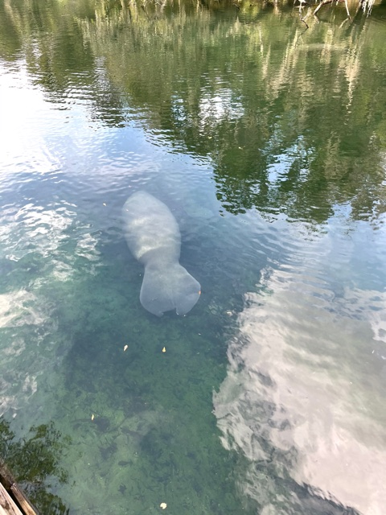

Manatees can grow to over 9 feet in length and weigh 1,000 lbs. Besides the manatees or "sea cows," fish abound in the spring run and attract a variety of wading birds, ospreys, eagles and kingfishers. The water here is crystal clear.

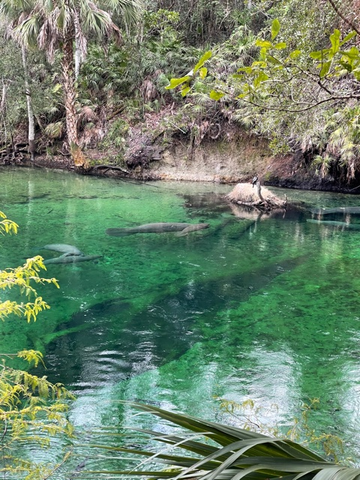

To see the park’s many wonders, visitors can hike along the spring run or on the 4.5-mile Pine Island Trail. There is great boardwalk to see these amazing creatures. There is also a nice gift shop and a place to grab a snack. Picnic tables are scattered around and many brought a picnic lunch with them. Visitors can also launch a canoe or kayak (rentals are available on site).

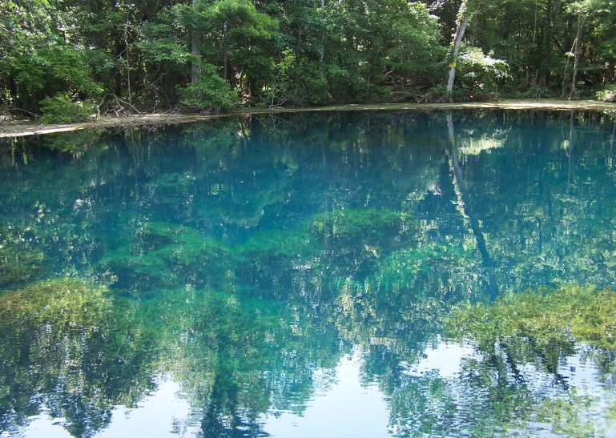



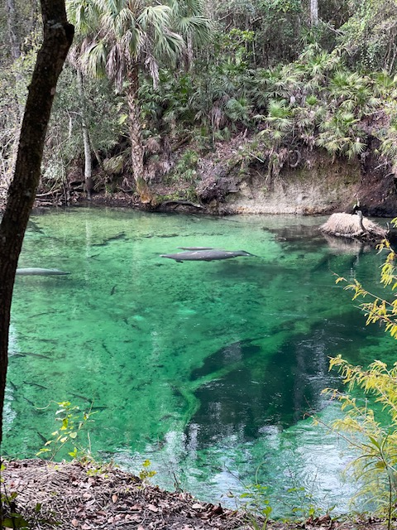

The address to Blue Springs State park is:

2100 W French Avenue  
Orange City FL 32763, (386) 775-3663



So, on Friday the 13th of November (go figure), my Facebook account got hacked. The hacker managed to change his (or her?) e-mail address to my account, thus not allowing me to access any of my pages, including the Southpoint accounts I’ve created and am admin to. Facebook offers no support or assistance at all so at this point I’m still unable to access the SP or the SP Owners pages. Hackers suck. Hopefully at some point in time I can undo what changes the hacker did to my accounts, until then, I continue to be MIA to our Facebook pages. So sorry that I can’t update or respond at this time.

**I wish you all a very happy, healthy and safe new year!**

**Best regards,**

**Linda Collette**

If you have any fun, exciting or newsworthy information you’d like to see in the next quarterly newsletter, please let me know! We love to see what other owners are up to. If you’d like to be in the SP Owners Spotlight, send me a brief bio and a picture or two. Send me a note to: [redcar@charter.net](mailto:redcar@charter.net)

Lastly, I’d like to say thank you so very much to SP President Phil Danley who has been at SP every day during renovations making sure things are getting done! He’s helped move furniture from balconies, checked on units being worked on, and so much more! He also had some help from Kenny Dow, so thank you too, Kenny for your assistance to fellow owners. Your help is very much appreciated, guys!



Owner Kevin Bailey has

created an e-mail list with owners names, unit #, e-mail address, telephone number and rental agency if you rent. If you’d like to be added to this list, please contact Kevin with your information at [kevinbail@bellsouth.net](mailto:kevinbail@bellsouth.net) and he’ll add you.



**Southpoint Condominium Association Board of Directors 2021**

Phil Danley, President - [phil.danley@gmail.com](http://mailto:phil.danley@gmail.com/)

Robert Shoemaker, Vice-President – Robshoey@aol.com

Judy Voiers, Secretary/Treasurer -

[jvoiers@tampabay.rr.com](http://mailto:jvoiers@tampabay.rr.com/)

Management Company: TJW Management Co, Inc.

Roger Koop, Manager and Maintenance Supervisor, 386-788-4546--[roger.koop@gmail.com](mailto:roger.koop@gmail.com) Karen Stewart - General Manager- kstewart@tjw.net

**Southpoint Rental Board Members**

Alan Powell, President

Judy Voiers, Vice President

Linda Collette, Secretary

Brenda Freznel, member